Dear authors!
The international publishing house «PITM» founded a medical scientific journal
«IMMORTALITY: MAGIC AND TECHNOLOGY».
The modern world perfectly demonstrates to us the accuracy of the statement of the English writer, scientist, futurist and inventor Arthur C. Clarke: «Any sufficiently advanced technology indistinguishable from magic». Nowadays, the outer and spiritual world are coming into greater harmony, thereby erasing the boundaries of the impossible for us.
The pages of the journal are a platform for discussions among experts and specialists, doctors and representatives of fundamental medicine, bioengineering, food technologies with philosophers, popularizers of science, representatives of business and biohacking on issues of technological rejuvenation of the body with subsequent life prolongation, methods of traditional and alternative medicine to achieve youth, longevity and immortality. In the publication, we will consider the practical application of new and long-forgotten technologies aimed at increasing human life expectancy, rejuvenation, improving physical and cognitive abilities in order to eliminate possible risks.

In this regard, we invite you to become one of our authors!
You can send your scientific articles by e -mail in .doc format to the email address pitm.tech@gmail.com.

INFROMATION FOR AUTHORS
REQUIREMENTS FOR THE REGISTRATION OF ARTICLES

The editorial board of the scientific medical journal «Immortality: Magic and Technology» (18+) continues to accept scientific papers and research materials.

You can send your scientific articles by e -mail in .doc format to the email address pitm.tech@gmail.com.
For publication in the journal, papers of at least 5 pages are accepted, without taking into account information about the author, performed both individually and by the author's team.

REQUIREMENTS FOR SENT FILES:
- Articles must be written in Microsoft Word.
- The file name must contain the author's surname and the title of the article
For example: Petrov_Science.doc
- There should be only one material in one file.

PLEASE NOTE:
- Texts placed in the body of the letter are not accepted.
- Articles for which the author has previously transferred exclusive rights to anyone are not accepted.
- Articles previously published are not considered.
- Articles with obscene language, excessive scenes of violence, explicit sexual scenes, as well as papers that violate the current legislation of the Russian Federation or discredit or devalue individuals and groups of persons on any basis (gender, age, religion, field of activity, race, nationality, etc.) are not accepted).

TECHNICAL REQUIREMENTS FOR THE ARTICLE:
(a sample of filling out the application is available in Appendix 1)
- The text of the article should be carefully proofread and edited. The articles are published in the author's editorial office. The authors are responsible for the scientific and theoretical level of the published material. The articles should be written in Microsoft Word. Both Russian and English languages are accepted. The volume of the author's text in the article should be more than 70%. For each article in Russian and English, the following information is required: the title of the article, full name and information about the authors (place of study, work, position, titles, academic degree, etc., as well as academic supervisor and information about him/her), an abstract, a list of keywords.
- The title is printed in capital letters. There is bold font and center alignment. Below, in one interval and in lowercase letters, there should be the surname, first name and patronymic of the author(s) (right alignment). On the next line, there should be the country and city, position, place of work (full name of the organization in the nominative case) of the author(s), academic titles (if any).
- After a paragraph indentation of 1 interval, an abstract follows. Then, after 1 interval, keywords, followed by the text of the article.
- After 1 interval, the text of the article follows.
- Not allowed: 1) page numbering; 2) automatic page-by-page footnotes to the references and other materials; 3) sparse or compacted letter spacing; 4) hyphenation.
- Sheet format is A4, sheet orientation is «portrait»
- Margins: 2 cm on all sides
- Main font: «Times New Roman»
- Font size of the main text: 14
- Line spacing: one-and-a-half
- Text alignment: left margin
- Paragraph indentation (red line): 1.25 cm. Paragraphs are divides by hyphenating to the next line with «Enter» key. It is unacceptable to use spaces and tabs for paragraph indentation.

- The names and numbers of the figures are indicated under the figures, the names and numbers of the tables are above the tables. The names of figures and tables are made out in «Times New Roman», size is 12, alignment is centered. The tables should also use «TimesNewRoman», size is 12, line spacing is single. Tables, diagrams, figures, graphs should not go beyond the specified fields.
- Footnotes to the references should be placed in square brackets.
- The list of references is obligatory. The list of references is arranged in alphabetical order in accordance with GOST.

You can order additional services:
- Coordination with the author of the page layout.
- Inset with a photo of the author(s) and comments on the article. Or an inset with a photo and a reviewer's comment.
- At the end of the article, information about the author should be indicated in the volume in which you want it to be published. The volume of published information may be changed at the discretion of the editorial board, including without the consent of the author.

INFORMATION ABOUT THE AUTHOR
In addition to the text of the work, you must send a file with information about the author:
- Surname, first name and patronymic of the author (in full);
- Alias, if any;
- Place of work or study;
- Age, education, work experience, available publications;
- E-mail address;
- Phone number;
- Do you need a printed copy of the journal with your article (specify the number);
- Postal address (don't forget about the ZIP code!);
- In the information about the author, it is necessary to specify whether to indicate the real full name or only a pseudonym when publishing an article in the journal;
- Passport data of the author for the conclusion of the contract;

PLEASE NOTE!
1. Files issued in violation of the above rules will not be accepted and will not be considered.
2. The editorial board informs about the decision made on specific materials only at the direct request of the author. The decision is not announced in the public network space.
3. Do not ask for what reasons your works were rejected. The reasons for the refusal are not explained.
4. Sending information about the author means unconditional consent to the processing (and storage) of the above-mentioned personal data by the editorial board of the journal in any way, including consent to the transfer of personal data by the journal for processing to affiliated persons of the journal and other persons with whom the journal enters into contracts related to the processing of personal data. Sending an article (file, papers) means unconditional consent to its publication in the journal «Immortality: Magic and Technology», posting on the Internet (including on the journal's website – pitm.tech); reproduction of the article (publication, publication, duplication, replication, as well as any other reproduction of the paper) without limiting the circulation of copies, while each copy of the article must contain the name of the author of the article; using the article by distributing and making available to the public, processing and systematization, as well as inclusion in various databases and information systems.
5. Authors send only their own works. All responsibility for the use of someone else's material and violation of the copyrights of third parties lies solely with the author who sent the file for consideration.
6. Articles in the journal «Immortality: Magic and Technology» are published on a non-fee basis. By sending the article(s) for consideration for publication, the author notes his consent to this type of publication, as well as agreement with all the working conditions in force in the editorial office of the journal «Immortality: Magic and Technology» (in particular, the terms of publication and posting on the Internet of the texts of articles).

APPENDIX 1.
File name: Ivanov, Sidorov_Title.doc

Title
Ivan Ivanovich Ivanov
Doctor of Economics, Professor,
Academy of Economic Sciences of Russia,
Russia, Moscow
Peter Petrovich Sidorov
Doctor of Economics, Professor,
Academy of Economic Sciences of Russia,
Russia, Moscow
Abstract. The article reveals various aspects of the phenomenon of entrepreneurship in the abstract form, namely: genetic-substantial, theoretical-conceptual, historical-evolutionary, structural-typological, functional-praxeological. Its content is a kind of introduction (main outline) to the general theory, evolution and typology of entrepreneurship, considered against an extremely large historical background, including modernity.
Keywords: entrepreneurship, business, neolithic revolution, archaic revolution, economic formula «property – enterprise – entrepreneurship», system of national entrepreneurship.
Title translation into English.
Translation into English of the full name and information about the authors (place of study, work, position, titles, academic degree, etc.)
Abstract.

Keywords:
Text. The following are not allowed in the provided text: page numbering; automatic page footnotes, sparse or compacted letter spacing and hyphenation.
Sheet format is A4, sheet orientation is «portrait». Margins: 2 cm on all sides. Main font: «Times New Roman». Font size of the main text: 14. Line spacing: one-and-a-half. Text alignment: left margin. Paragraph indentation (red line): 1.25 cm.

Paragraphs are divides by hyphenating to the next line with «Enter» key. It is unacceptable to use spaces and tabs for paragraph indentation.
The name and numbers of the figures are indicated under the figure.
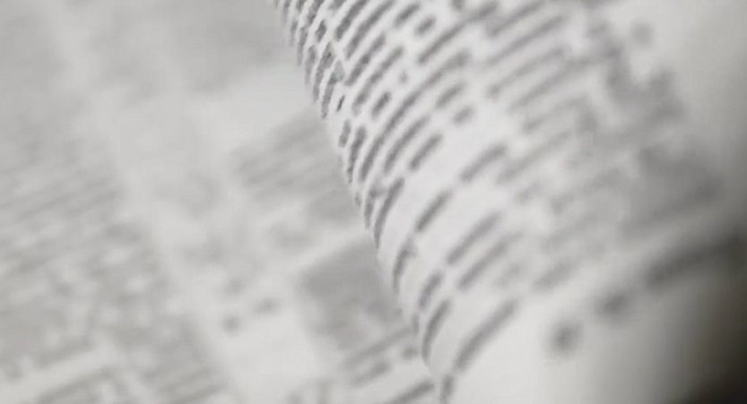
Fig. 1. Illustration of printed pages

Table 1. Numbering from 1 to 10.
1 | 2 | 3 | 4 | 5 | 6 | 7 | 8 | 9 | 10

The names of figures and tables are made out in «Times New Roman»; size is 12, alignment is centered. The tables should also use

«Times New Roman», size is 12, line spacing is single. Tables, diagrams, figures, graphs should not go beyond the specified fields.
Footnotes to the references should be placed in square brackets [Petrov A.A., ed. Moscow, 1999 – Short Stories].
References:
1….
2….

You can order additional services:
1. Coordination with the author of the page layout.
2. Inset with a photo of the author(s) and comments on the article. Or an insert with a photo and a reviewer's comment.
At the end of the article, information about the author should be indicated in the volume in which you want it to be published. The volume of published information may be changed at the discretion of the editorial board, including without the consent of the author.
Information about the author:
Ivanov Ivan Ivanovich, passport 2008 999444, issued by Department of Federal Migration Service of Russia in Moscow, May 12, 2000.
Please specify the author of the article: Ivanov Ivan Ivanovich.
ООО «Writer»
40 years old, higher education (MSU, Faculty of Journalism), 21 years in the profession, 10 publications.
ivanovivan@mail.
+7 (900) 000 - 00 - 00
Please provide me with 10 printed copies of the journal at the following address: 012345, Moscow, 20-74 Sirenevaya street.

